|  |
| --- |
| **SOFTWARE PERSONNEL MANAGEMENT SYSTEM** |

# AIM:

To draw the diagrams [usecase, activity, sequence, collaboration, class] for Software

personnel management system

# PROJECT DESCRIPTION:

This software is designed for the process of knowing the details of a person works in a software company. The details are being stored in the central management system for the crosschecking the person’s details.

# USE CASE DIAGRAM:

This diagram will contain the actors, use cases which are given below

**Actors**: Employee, HR, Central system.

**Use case**: Name and address ,qualification ,experience, internet, loan, verification

# ACTIVITY DIAGRAM:

This diagram will have the activities as Start point ,End point, Decision boxes as given below:

**Activities**: Enter the option to check, enter the salary, enter the working days ,leave taken ,loss of pay

**Decision box:** Option to check

# CLASS DIAGRAM:

This diagram consists of the following classes, attributes and their operations.

|  |  |  |
| --- | --- | --- |
| **CLASSES** | **ATTRIBUTES** | **OPERATIONS** |
| Central management system | Employeename,  Employeenumber | Tax()  Loan() |
| Employee1 | Employee details | Leave taken() |
| HR | checkdetails | Loss of pay() |

# SEQUENCE DIAGRAM:

This diagram consists of the objects, messages and return messages.

**Object :**Employee, HR, Central system

# COLLABORATION DIAGRAM:

This diagram contains the objects and actors. This will be obtained by the completion of the sequence diagram and pressing the F5 key.

# MERITS:

* Provides convenience.
* Easily understandable.
* User friendliness.

# DEMERITS:

* + Need computer knowledge.
  + It is complex for large scale products.

# SOFTWARE PERSONNEL MANAGEMENT SYSTEM. USE CASE DIAGRAM:

**NAME AND ADDRESS**



**QUALIFICATION**

**EMPLOYEE**

**EXPERIENCE**

**HR CENTRAL MANAGEMENT**

**SYSTEM**

**INTEREST**

**LOAN**

**VERIFICATION**

# CLASS DIAGRAM:

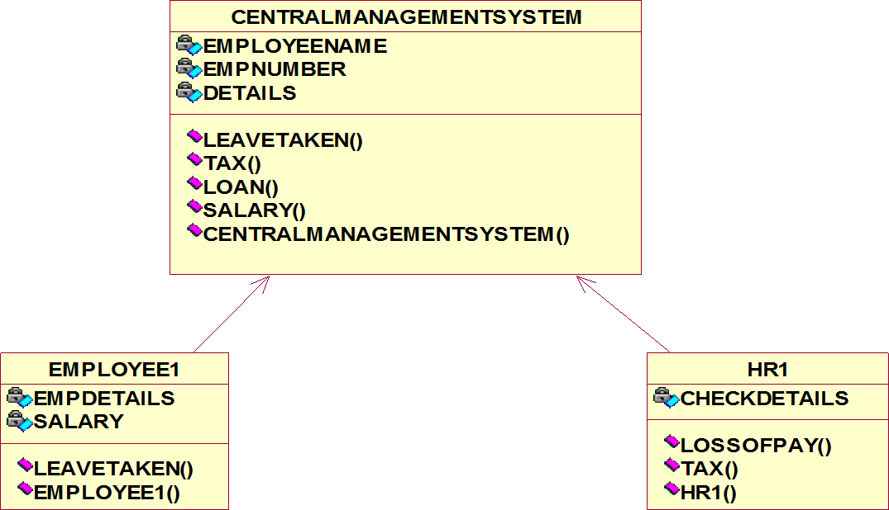

**ACTIVITY DIAGRAM:**

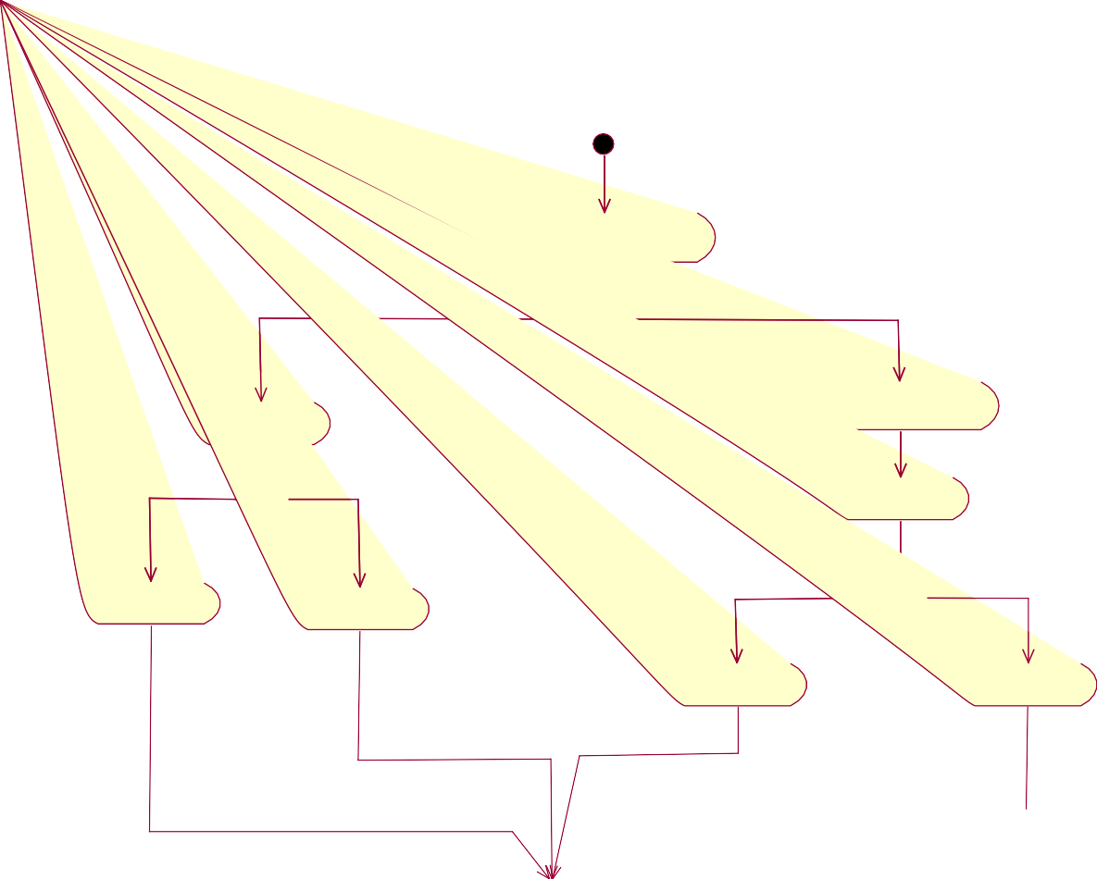

**ENTER THE OPTION TO CHECK**

**ENTER THE SALARY**

**ENTER NUMBER OF WORKING DAYS**

**LEAVE TAKEN**

**2% LOAN**

**5% LOAN**

**LOSS OF PAY**

**CREDIT FULL SALARY**

**SALARY DETAILS**

**SEQUENCE DIAGRAM:**

**ENTER THE OPTION**

**ENTER THE SALARY**

**WHETHER EXCEEDS 10000**

**SALARY EXCEEDS 10000 CALCULATE TAX AMOUNT**

**TAX CALCULATED**

**DISPLAY TAX AMOUNT**

**ENTER THE LOSS OF PAY**

**ENTER NUMBER OF LEAVE TAKEN**

**CALCULATE LOSS OF PAY**

**DISPLAY LOSS OF PAY**

**PRINT SALARY**

**CENTRAL**

**SYSTEM**

**HR**

**EMPLOYEE**

**COLLOBORATION DIAGRAM:**

**1: ENTER THE OPTION**

**2: ENTER THE SALARY**

**8: ENTER THE LOSS OF PAY**

**9: ENTER NUMBER OF LEAVE TAKEN**

|  |  |  |
| --- | --- | --- |
| **EMPLOYE E** |  | **HR** |
|  |

**7: DISPLAY TAX AMOUNT**

**12: PRINT SALARY**

**4: SALARY EXCEEDS 10000**

**6: TAX CALCULATED**

**11: DISPLAY LOSS OF PAY 3: WHETHER EXCEEDS 10000**

**5: CALCULATE TAX AMOUNT**

**10: CALCULATE LOSS OF PAY**

**CENTRAL**

**SYSTEM**

**HR.JAVA**

//Source file: Z:\\SACHIN\\HR.java

public class HR extends Employee

{

   private int CurriculumVitae;

   private int MonitorEmployees;

   private int ProvideSalaryIncrement;

   private int Motivate;

   /**

   @roseuid 4D5E0BDF005F

    */

   public HR()

   {

   }

    /**

   @roseuid 4D2D35EE0105

    */

   public void Recruit()

   {

   }

   /**

   @roseuid 4D2D36120008

    */

   public void Monitor()

   {

   }

   /**

   @roseuid 4D2D361703C1

    */

   public void Increment()

   {

   }

   /**

   @roseuid 4D2D362301BC

    */

   public void Motivation()

   {

   }

}

**EMPLOYEE.JAVA**

//Source file: Z:\\SACHIN\\Employee.java

public class Employee

{

   private int Commitment;

   private int BankAccounts;

   private int Regularity;

   public HR theHR;

   /**

   @roseuid 4D5E0BE0006E

    */

   public Employee()

   {

   }

   /**

   @roseuid 4D2D36DE0372

    */

   public void Training()

   {

   }

   /**

   @roseuid 4D2D36F20370

    */

   public void Salary()

   {

   }

   /**

   @roseuid 4D2D36F80062

    */

public void Performance()

   {

   }

}

**SALARYDETAILS.JAVA**

//Source file: Z:\\SACHIN\\SalaryDetails.java

public class SalaryDetails extends HR

{

   private int createBankAccountToDepositSalary;

   /**

   @roseuid 4D5E0C0C036C

    */

   public SalaryDetails()

   {

   }

   /**

   @roseuid 4D2FDFEC0109

    */

   public void salary()

   {

   }

}

# RESULT:

Thus the diagrams[Use case, class, activity, sequence, collaboration] for the Software personnel management system has been designed ,executed and output is verified.